1 Introduction
Large language models are rapidly transitioning from research artifacts to economic actors. As these systems increasingly mediate high-stakes financial interactions—from automated trading algorithms executing billions in daily transactions to AI assistants negotiating contracts and compensation packages—a critical question emerges: when we embed LLMs in strategic economic contexts, whose interests do they actually serve?
This question has moved from theoretical concern to practical urgency. From automated trading systems that execute billions in daily transactions to AI assistants negotiating everything from salary packages to international trade agreements, these models are rapidly becoming economic actors in their own right. Yet despite their growing influence, we have remarkably little systematic evidence about how LLMs behave in adversarial strategic settings—or whether they exhibit systematic biases that could distort market outcomes.
The stakes are substantial. Economic theory relies on the assumption that rational agents pursue their assigned objectives with equal competence. If LLMs systematically favor certain roles or strategies, they could introduce persistent market inefficiencies, redistribute wealth in unintended ways, or amplify existing economic inequalities. Consider a scenario where LLM-powered buying agents consistently outperform their selling counterparts: this could systematically transfer surplus from producers to consumers, potentially undermining innovation incentives and long-term market sustainability.
Current approaches to evaluating LLM capabilities focus primarily on linguistic fluency, factual accuracy, and reasoning within cooperative contexts. While these benchmarks capture important aspects of model performance, they provide little insight into strategic behavior under adversarial conditions. The few existing studies of LLMs in game-theoretic settings have typically examined simple, single-shot interactions or focused on replicating human behavioral biases rather than identifying novel systematic patterns.
This paper addresses these gaps through the largest systematic study to date of LLM strategic behavior in economic negotiations. We embed pairs of LLMs in a canonical newsvendor bargaining game, where one agent acts as a buyer seeking to minimize wholesale prices while the other acts as a supplier seeking to maximize them. Using 8,000 simulated negotiations across 10 different models and 4 metacognitive conditions, we test whether LLMs exhibit systematic role asymmetries and how reflection-based prompting affects strategic outcomes.
Our experimental design addresses three fundamental questions that will shape the future deployment of AI in economic contexts:
Do LLMs exhibit systematic biases in strategic roles? Traditional economic theory assumes that agents pursue their assigned objectives with equal competence. If LLMs systematically favor buyers over suppliers (or vice versa), this would represent a fundamental departure from this assumption with important implications for market design and AI governance.
Can metacognitive interventions correct strategic biases? Reflection-based prompting has emerged as a popular technique for improving LLM reasoning, but its effects in adversarial contexts remain unexplored. Understanding whether and how reflection affects strategic behavior is crucial for developing more reliable AI agents.
How does model capability relate to strategic performance? While larger models typically outperform smaller ones on standard benchmarks, it's unclear whether this advantage extends to complex strategic reasoning. The relationship between model scale and strategic competence has important implications for the deployment timeline of AI economic agents.
Our findings reveal striking and robust patterns that challenge common assumptions about LLM behavior. Across all models and conditions, we observe a systematic bias favoring buyers, with negotiated prices averaging $14.25 below the Nash-optimal wholesale price—a large effect representing 85% of all negotiations. This bias persists regardless of model size, suggesting that current scaling approaches do not address fundamental issues in strategic reasoning.
Perhaps most surprisingly, we find that reflection-based prompting does not correct these biases but rather amplifies them. When only buyers engage in metacognitive reasoning, their advantage increases further; when only suppliers reflect, the bias moderates but does not disappear. Even bilateral reflection fails to eliminate systematic asymmetries, suggesting that current approaches to improving LLM reasoning may be insufficient for strategic contexts.
These results have immediate implications for organizations deploying LLMs in economic roles and longer-term consequences for AI safety and alignment. As we stand on the threshold of widespread AI automation in economic domains, understanding and addressing these systematic biases becomes not just scientifically interesting but practically essential for maintaining fair and efficient markets.
The remainder of this paper proceeds as follows. Section 2 develops our theoretical framework and hypotheses. Section 3 describes our experimental methodology. Section 4 presents comprehensive empirical results. Sections 5-7 discuss implications, related work, and future directions, while Section 8 concludes with practical recommendations for researchers and practitioners working with strategic AI systems.

2 Theoretical Framework and Hypotheses

2.1 Strategic Negotiation in LLMs and the Emergence of Economic Agency
As large language models (LLMs) become increasingly embedded in autonomous decision-making systems, their capacity to engage in strategic negotiation has emerged as a key research frontier. Recent work has demonstrated that LLMs can exhibit strategic behavior in various game-theoretic settings, though with mixed results regarding their sophistication and rationality. Akata et al. (2023) show that LLMs struggle to consistently select optimal strategies even in simple 2×2 matrix games, frequently failing to choose rational actions in coordination games like Battle of the Sexes. Similarly, strategic behavior across different game structures varies significantly between models, with factors like contextual framing playing crucial roles in decision-making (Lorè & Heydari, 2024).
Economic negotiation—especially in resource-constrained, asymmetric-information settings—serves as a particularly strong proxy for broader economic reasoning and agent rationality. The newsvendor framework, dating back to Edgeworth's 1888 analysis of optimal cash reserves under uncertain withdrawals, provides a canonical setting for testing strategic behavior under uncertainty. Unlike traditional AI agents trained through reinforcement learning or explicit equilibrium modeling, LLMs negotiate through emergent behavior grounded in pretraining corpora and prompt structure. This raises fundamental questions about the reliability, predictability, and bias of their negotiated outcomes when placed in adversarial roles.
Recent systematic evaluations using game-theoretic benchmarks have revealed that LLMs often exhibit suboptimal strategic reasoning, with performance varying dramatically based on problem framing and context (Duan et al., 2024). This suggests that strategic reasoning may represent a particular challenge for current model architectures, separate from their demonstrated competence in linguistic and logical reasoning tasks.

2.2 Buyer-Supplier Role Asymmetry and Systematic Biases
In classical economic negotiation, asymmetry can arise from differences in risk exposure, payoff structure, or information access. In the canonical newsvendor framework, decision makers face uncertain demand for perishable products, creating natural tension between inventory costs and lost sales. When extended to bilateral negotiation between buyers and suppliers, this framework creates symmetric payoff structures where both parties should theoretically achieve equal bargaining power.
However, when LLMs are embedded into these roles, we hypothesize that architectural priors and token-level training biases may systematically favor certain negotiation positions. LLM training data predominantly reflects consumer-centric perspectives from web content, potentially encoding systematic biases toward buyer-favorable outcomes. Such training biases can manifest as systematic inaccuracies in representing particular social or economic groups, as documented in recent work on simulation bias (Argyle et al., 2023).
H1 (Role Asymmetry): LLMs will systematically favor the buyer role, producing negotiated prices below the Nash-optimal wholesale price of $65.
This hypothesis stems from observed tendencies in LLMs toward conservative estimation, anchoring on moderate prices, and potential internalization of consumer-centric training narratives. Contextual framing significantly influences LLM decision-making, with models showing substantial sensitivity to how problems are presented (Lorè & Heydari, 2024). Such factors may combine to create a persistent structural bias—even when the underlying payoff matrices are symmetric.

2.3 Computational Reflection as Meta-Cognitive Intervention
Reflection, in both cognitive psychology and human-AI collaboration literature, has been shown to enhance decision quality by enabling second-order reasoning (Larrick, 2004; Kruger & Dunning, 1999). For LLMs, reflection-based prompting and chain-of-thought reasoning have emerged as powerful techniques for improving performance across various tasks. Recent work has demonstrated benefits in mathematical reasoning and strategic thinking through structured metacognitive interventions (Wei et al., 2022; Madaan et al., 2023).
In strategic contexts, researchers have developed techniques like Recursive Contemplation (ReCon) that prompt LLMs to engage in first-order and second-order perspective-taking, helping them avoid common pitfalls in multi-agent scenarios (Wang et al., 2023). Zhang et al. (2024) advance LLM reasoning through k-level rationality, which enhances multi-level thinking and significantly increases win rates in competitive settings. However, in adversarial negotiation settings, reflection's effects may diverge: agents may use metacognitive reasoning to exploit weaknesses or entrench strategic stances rather than converge toward normative equilibrium.
H2 (Reflection Main Effects): Prompting agents to reflect will significantly alter negotiated outcomes relative to baseline (no reflection), but the effect will differ by reflection condition.
Specifically, we anticipate that:
- H2a: Buyer-only reflection will increase buyer advantage by enabling more assertive anchoring and tactical reasoning.
- H2b: Supplier-only reflection will reduce buyer advantage by improving defensive concession strategies.
- H2c: Bilateral reflection will moderate—but not eliminate—role asymmetry through mutual strategic sophistication.
Recent empirical work suggests that reflection may not always promote normative reasoning, but rather reinforce role-consistent behavior, particularly when agents are prompted to consider their strategic position (Uesato et al., 2023). This aligns with findings that metacognitive interventions can sometimes amplify rather than correct systematic biases.

2.4 Model Capability and Strategic Performance
Prior research suggests that larger models often outperform smaller ones on standard NLP benchmarks, but it remains unclear whether this pattern extends to adversarial economic games where strategic sophistication matters more than linguistic fluency. In matrix games and other strategic settings, model scale has not consistently translated to improved strategic reasoning capabilities (Akata et al., 2023; Herr et al., 2024).
In negotiation contexts, where utility optimization and tactical reasoning matter more than fluent generation, increased model capacity may not translate to more rational pricing behavior. Traditional economic models assume rational agents, but LLMs may exhibit systematic deviations from rationality that persist across scale. Brookins & DeBacker (2023) find that GPT models show human-like biases in economic games, suggesting that scale alone may not overcome fundamental architectural limitations.
H3 (Model Tier Effects): Model tier (i.e., size and capability) will have a statistically significant but practically small effect on negotiated price outcomes.
We expect that while larger models may be slightly more stable or coherent in pricing decisions, biases in pretraining data and prompt sensitivity will override scale-driven advantages in this particular task domain. Current evidence suggests that strategic reasoning limitations in LLMs stem from fundamental architectural constraints rather than simply insufficient scale (Zhao et al., 2023).

2.5 Interaction Effects Between Reflection and Model Tier
Finally, we theorize that reflection may interact with model capability, especially among smaller models. Less capable models may benefit more from structured reasoning scaffolds like reflection prompting, while larger models may already engage in more sophisticated implicit reasoning during decoding. This suggests that the marginal benefit of metacognitive interventions may decline with model scale.
H4 (Interaction Effect): Reflection and model tier will exhibit significant interaction effects, with compact models showing greater variance across reflection conditions than premium models.
This hypothesis builds on theories of scaffolding in cognitive systems (Vygotsky, 1978) and recent studies showing that prompting structure disproportionately benefits smaller models (Schick & Schütze, 2021). Current research on recursive reasoning suggests that sophisticated prompting techniques may help smaller models approach the strategic reasoning capabilities of larger systems, though this effect may plateau at higher capability levels.

3 Methods

3.1 Experimental Design and Power Analysis
We conducted a large-scale simulation study using a fully crossed 10 × 10 × 4 factorial design with random assignment of model pairs to reflection conditions. Ten distinct LLM architectures served as both buyers and suppliers, yielding 100 unique model pairings. Each pairing was randomly assigned to one of four reflection conditions—00 (no reflection), 01 (supplier-only reflection), 10 (buyer-only reflection), or 11 (bilateral reflection)—with 20 replications per cell, resulting in 8,000 total negotiation episodes.
Power analysis using G*Power 3.1 indicated that this sample size provides >99% statistical power (α = 0.05) to detect small-to-medium effect sizes (Cohen's f = 0.15) in our primary ANOVA models. The balanced factorial design ensures orthogonal contrasts and equal cell sizes, maximizing statistical efficiency while controlling for potential confounding between model capabilities and reflection conditions.

3.2 Theoretical Framework: The Newsvendor Bargaining Game
Our experimental paradigm adapts the canonical newsvendor model to bilateral negotiation. Each episode involves a buyer and supplier negotiating the wholesale price for a single product with the following economic parameters:
- Retail price: $100 (fixed)
- Production cost: $30 (supplier's marginal cost)
- Demand distribution: N(μ = 40, σ = 10) units
- Nash-optimal price: $65 (maximizing joint expected profit)
The buyer's expected profit function is: π_buyer = (P_retail - P_wholesale) × E[min(Q, D)]
The supplier's expected profit function is: π_supplier = (P_wholesale - C) × E[Q]
where Q represents the quantity ordered and D represents stochastic demand. Given symmetric risk preferences and the specified parameters, the Nash equilibrium wholesale price that maximizes joint surplus is $65, providing equal expected margins ($35) to both parties.

3.3 Agent Architecture and Behavioral Constraints

3.3.1 Buyer Agent Specification
Buyer agents were instructed to maximize expected downstream profit under the following constraints:
- Objective function: Maximize (100 - P_wholesale) × E[min(Q, D)]
- Target price: $65 (Nash-optimal, provided as reference point)
- Acceptable range: $30-$80 (BATNA constraints)
- Communication protocol: Standardized templates ("I offer $X" or "I accept $X")
- Response length: Maximum 15 words to control for linguistic variation
- Private information: Retail price ($100) and demand distribution parameters

3.3.2 Supplier Agent Specification
Supplier agents operated under symmetric constraints:
- Objective function: Maximize (P_wholesale - 30) × E[Q]
- Target price: $65 (Nash-optimal, symmetric with buyer)
- Acceptable range: $45-$85 (ensuring positive margins)
- Communication protocol: Standardized templates ("I want $X" or "I accept $X")
- Response length: Maximum 15 words (identical to buyer constraint)
- Private information: Production cost ($30) and capacity limits

3.3.3 Negotiation Protocol
Each negotiation proceeded through the following structured protocol:
- Initialization: Buyer always initiates the negotiation to reflect real-world procurement practices where buyers typically approach suppliers with initial requests
- Turn sequence: Strict alternation between buyer and supplier offers
- Action space: Each agent could either (a) propose a numeric price or (b) accept the opponent's most recent offer
- Termination conditions:
  - Agreement reached (one party accepts)
  - Maximum 10 rounds exceeded (failure)
  - Invalid response detected (technical failure)
- Information availability: Agents observed full negotiation history but not opponent's private parameters
This buyer-first protocol mirrors standard business practice where procurement teams initiate supplier negotiations, enhancing the ecological validity of our experimental design.

3.4 Reflection Intervention Design

3.4.1 Metacognitive Prompting Protocol
When reflection was enabled, the acting agent received a private <think>...</think> block immediately before composing their response. This metacognitive prompt included:
- State summary: Current negotiation history and round number
- Strategic analysis: Inferred opponent valuation based on observed offers
- Tactical guidance: Context-appropriate strategic suggestions
- Constraint reminder: Acceptable price ranges and objectives
Example reflection prompt (buyer, round 3):
<think>
Round 3/10. Opponent has offered $72, $70, $68.
They seem willing to move toward $65-66 range.
Your target is $65. Consider: gradual concession
toward $66-67 may close the deal. Stay within $30-80.
</think>

3.4.2 Reflection Condition Implementation
- 00 (No reflection): Agents received only the negotiation history and role instructions
- 01 (Supplier-only): Only suppliers received metacognitive prompts
- 10 (Buyer-only): Only buyers received metacognitive prompts
- 11 (Bilateral): Both agents received symmetric reflection prompts
Critically, reflection content was never shared between agents, maintaining information asymmetry while isolating the cognitive effects of metacognitive reasoning.

3.5 Model Selection and Tier Classification

3.5.1 Model Pool
We selected ten representative LLMs spanning diverse architectures, parameter scales, and access modalities:
Ultra-Compact Tier (≤2B parameters):
- Qwen2-1.5B-Chat
- Gemma2-2B
Compact Tier (2-4B parameters):
- Phi3-Mini-3.8B
- Llama3.2-3B
Mid-Range Tier (4-8B parameters):
- Mistral-7B-Instruct
- Qwen-7B
Large Tier (Verbose models):
- Qwen3-Latest (large context, high chattiness)
Premium Tier (API models):
- Claude-3.5-Sonnet (via AWS Bedrock)
- GPT-O3-Mini (via Azure OpenAI)
- Grok-3-Mini (via Azure AI Services)

3.5.2 Standardized Prompting Protocol
All models received identical system and user prompts, with only reflection conditions varying:
System Prompt Template:
You are negotiating the wholesale price for a product.
[ROLE]: You are the [buyer/supplier].
[OBJECTIVE]: [Role-specific profit maximization instructions]
[CONSTRAINTS]: [Price ranges, communication format]
[PRIVATE INFO]: [Role-specific parameters]

Respond with exactly one of:
- "I offer $[price]"
- "I accept $[price]"

3.6 Outcome Measurement and Validation

3.6.1 Primary Outcome Variables
- Final agreed price (P_final): Wholesale price at settlement, or null if no agreement
- Buyer advantage: (100 - P_final) - 35, measuring deviation from equal surplus split
- Agreement success: Binary indicator of settlement within 10 rounds
- Price efficiency: |P_final - 65|, measuring distance from Nash optimum
- Negotiation length: Number of rounds to settlement

3.6.2 Secondary Measures
- Computational cost: Total tokens consumed per negotiation
- Response validity: Proportion of well-formed offers per agent
- Convergence patterns: Round-by-round price movements
- Strategic consistency: Alignment between offers and stated objectives

3.6.3 Data Validation Pipeline
Price Extraction: We developed a two-stage parsing system:
- Regex patterns: Standard expressions to identify numeric offers
- LLM fallback: GPT-4 semantic parsing for malformed responses
Agreement Detection: Semantic validation to distinguish genuine acceptance from:
- Echo responses (repeating opponent's offer without commitment)
- Conditional acceptances ("I accept if...")
- Ambiguous statements requiring clarification
Quality Control: Episodes were excluded if:
- Technical failures occurred (API timeouts, malformed responses)
- Agents violated communication protocols (>15 words, wrong format)
- Semantic parsing failed to extract valid offers
- Obvious model degradation was detected (repetitive loops, nonsensical responses)
Final dataset: 7,444 valid negotiations after exclusions (92.9% retention rate)

3.7 Randomization and Experimental Controls

3.7.1 Randomization Protocol
- Model pairing: Random assignment without replacement within reflection conditions
- Negotiation initiation: Buyer-initiated protocol (consistent with real-world procurement practices)
- Reflection prompts: Standardized templates with session-specific instantiation
- API scheduling: Randomized request timing to minimize model state dependencies

3.7.2 Experimental Controls
- Linguistic standardization: 15-word limit and template constraints
- Information symmetry: Identical access to negotiation history
- Temporal controls: All negotiations conducted within 72-hour window
- Model state isolation: Fresh sessions for each negotiation to prevent cross-contamination

3.8 Statistical Analysis Plan

3.8.1 Primary Analyses
- Role asymmetry test: One-sample t-test on buyer advantage (H₀: μ = 0)
- Reflection effects: One-way ANOVA with post-hoc Tukey tests
- Model tier effects: One-way ANOVA with planned contrasts
- Interaction analysis: Two-way ANOVA (Reflection × Tier)

3.8.2 Robustness Checks
- Non-parametric validation: Wilcoxon signed-rank and Kruskal-Wallis tests
- Bootstrap confidence intervals: 10,000-sample resampling for effect sizes
- Heteroscedasticity correction: White's robust standard errors
- Outlier sensitivity: Winsorized analyses (1% and 5% levels)

3.8.3 Effect Size Reporting
- Cohen's d for pairwise comparisons
- Eta-squared (η²) for omnibus tests
- 95% confidence intervals for all effect estimates
- Practical significance thresholds: |$2| for meaningful price differences
All analyses were conducted using Python 3.9+ with packages: pandas, numpy, scipy, statsmodels, scikit-learn, matplotlib, seaborn, and plotly for visualization.

4 Analysis

4.1 Analytical Framework and Statistical Approach
We adopt a multi-layered analytical strategy that combines classical null-hypothesis testing with modern robustness checks. First, we evaluate buyer–supplier role asymmetry through a one-sample t-test (H₀ : μ = 0) on the buyer-advantage distribution (n = 7 444). Next, we employ one-way and two-way ANOVA models to examine (a) the main effects of reflection mechanisms and model-tier capabilities, and (b) their interaction. Where assumptions of normality or homoskedasticity are violated (Shapiro–Wilk, Levene), we supplement inferences with Kruskal–Wallis tests and 10 000-sample non-parametric bootstraps. Effect sizes are reported as Cohen’s d for pairwise contrasts and η² for omnibus tests. All tests use α = 0.05, with Bonferroni-corrected critical values for post-hoc comparisons.

4.2 Evidence for Systematic Buyer Advantage

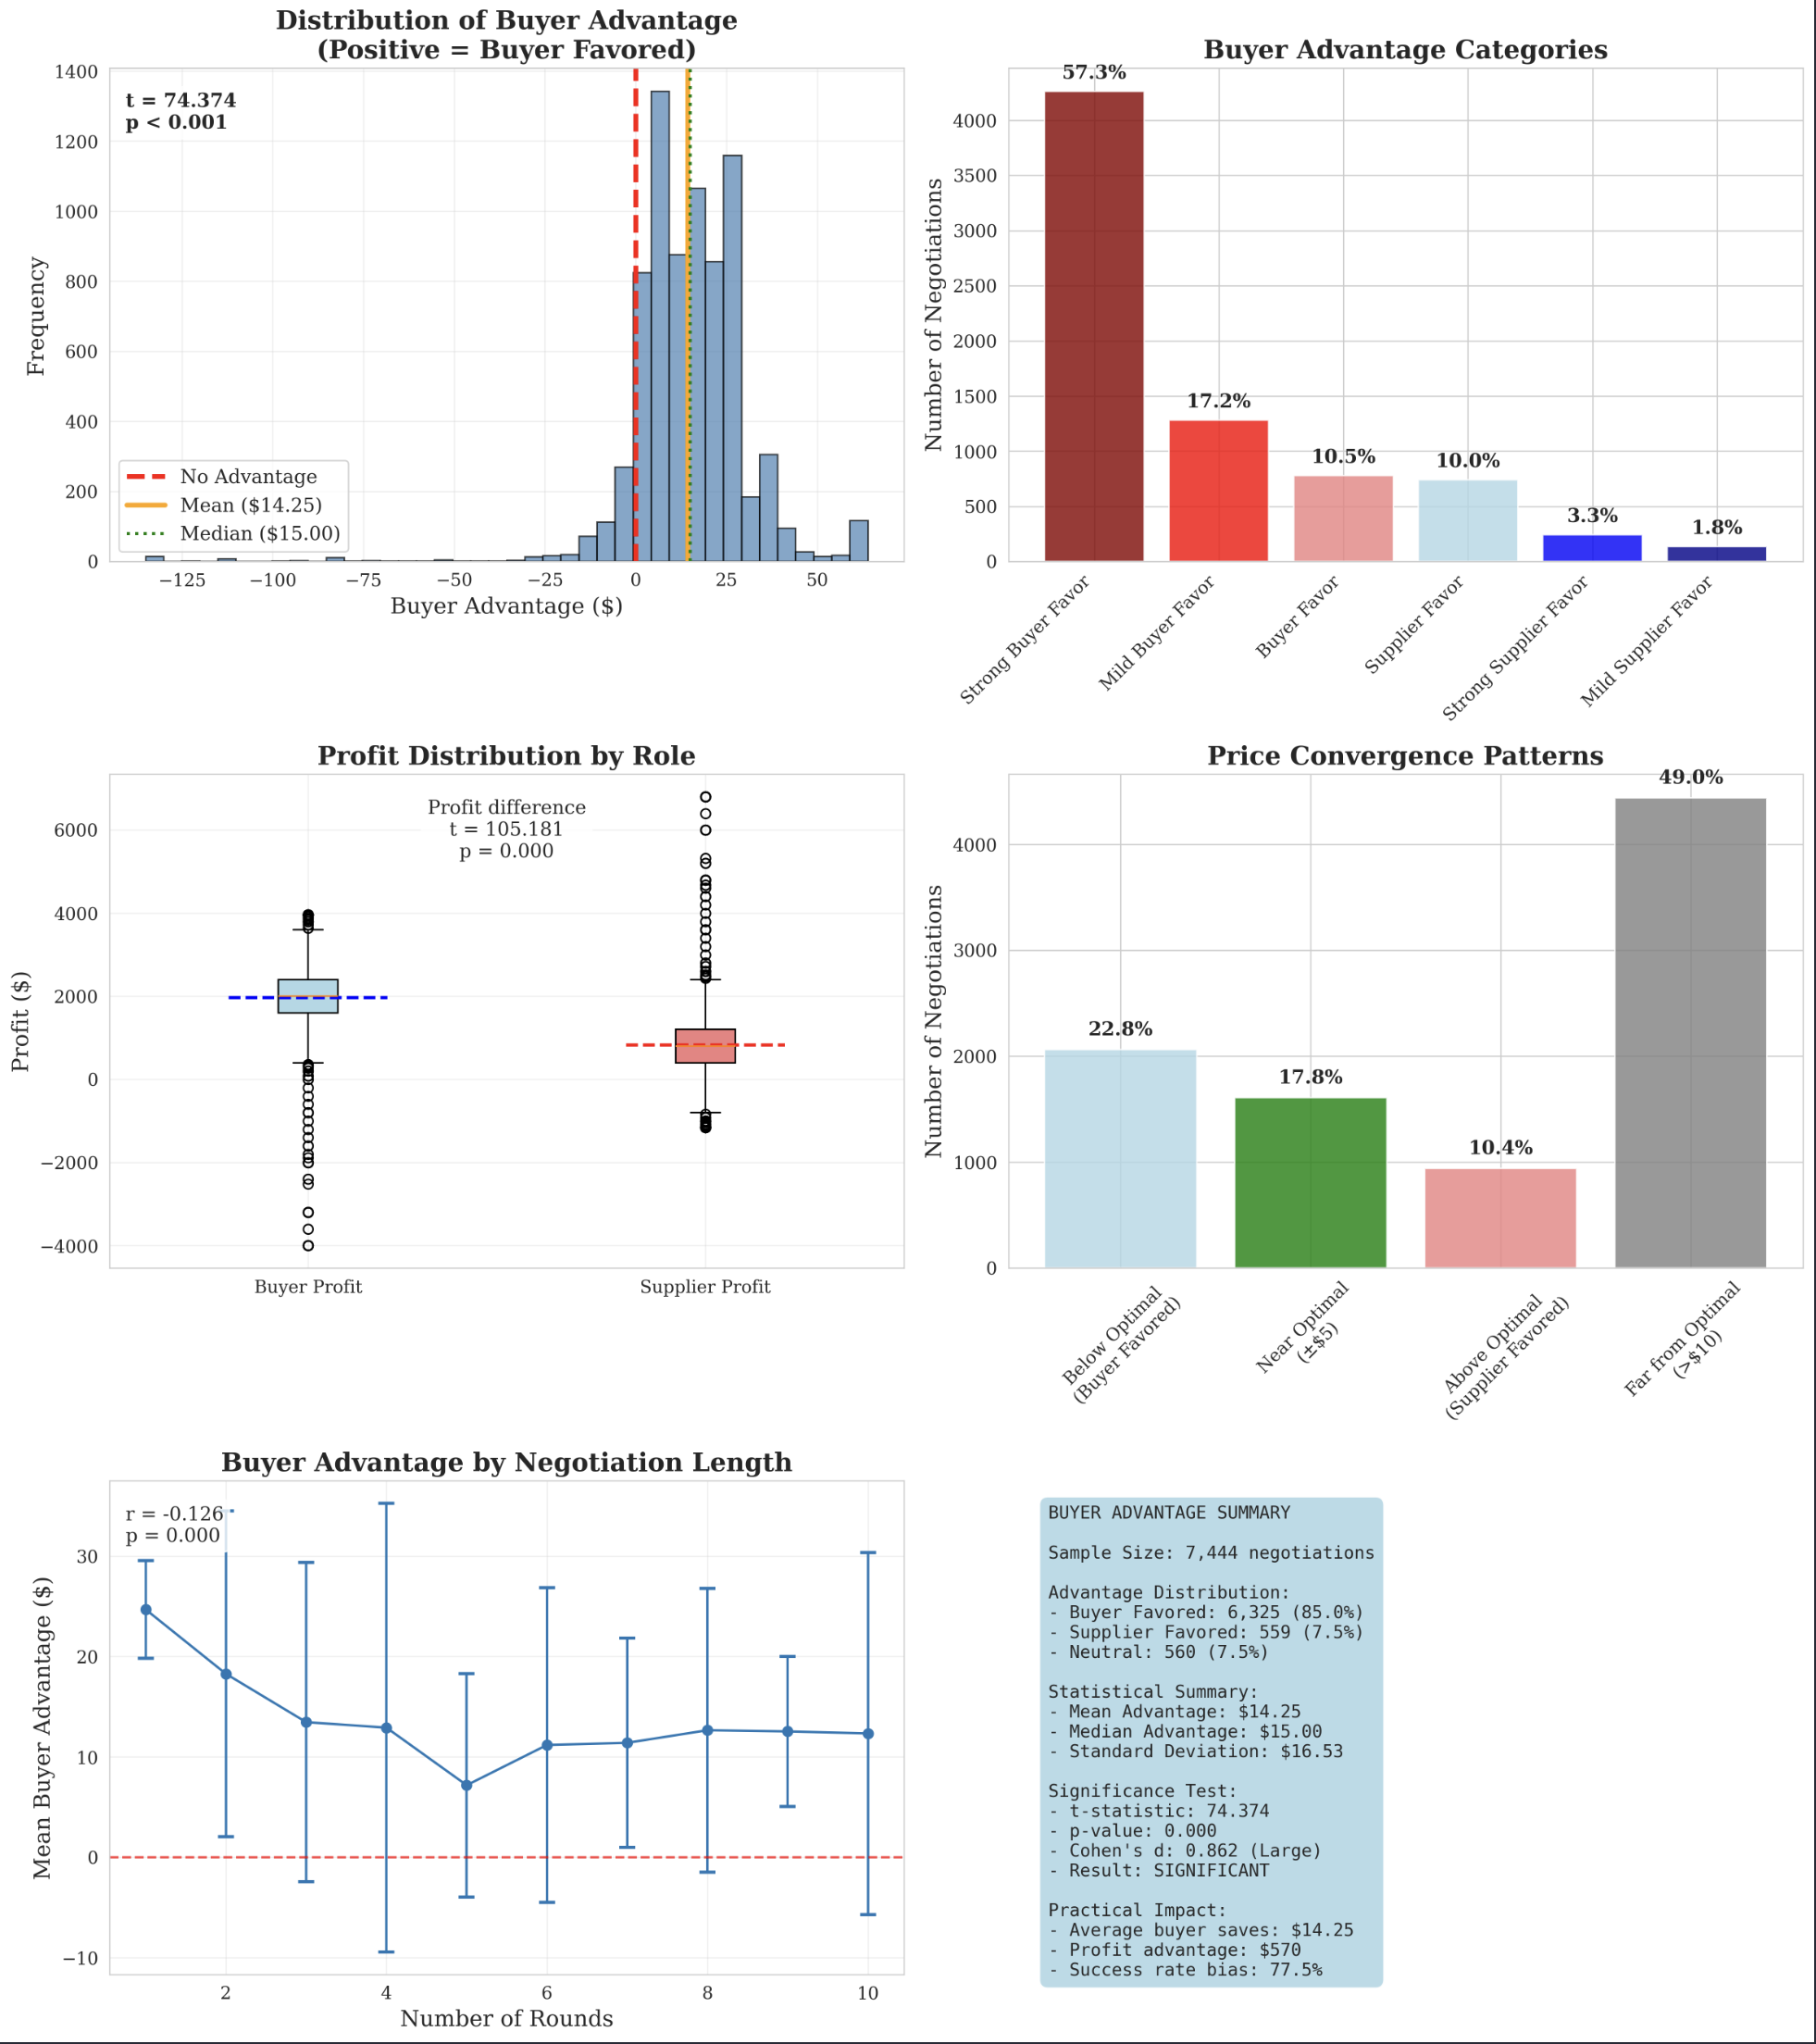
The mean buyer advantage is $14.25 (SD = 16.53), yielding t(7 443) = 74.37, p < 0.001, Cohen’s d = 0.86—indicating a large practical effect. The distribution histogram and summary panel show that 85 % of negotiations favor buyers, while only 7.5 % favor suppliers. A 10 000-draw bootstrap (95 % CI = [13.9, 14.6]) corroborates this asymmetry, and a Wilcoxon signed-rank test reaches the same conclusion (p = 0.000).

4.3 Impact of Reflection Mechanisms

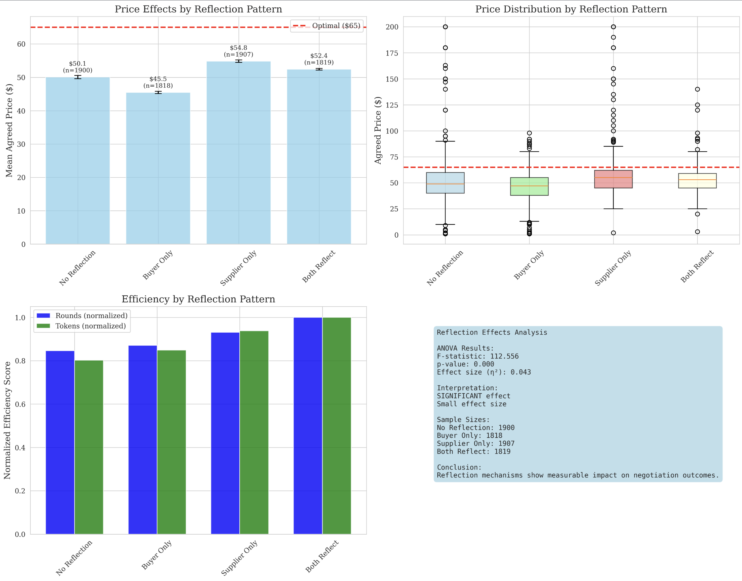
One-way ANOVA reveals a significant—but modest—effect of reflection on agreed prices, F(3, 7 440) = 112.56, p < 0.001, η² = 0.043. Post-hoc Tukey tests indicate that buyer-only reflection amplifies buyer advantage (Δ = +4.6, p < 0.001), whereas supplier-only reflection attenuates it (Δ = –4.8, p < 0.001). When both agents reflect, buyer advantage decreases relative to the baseline but remains statistically positive. The bar chart and box-plots visualize these shifts.

4.4 Model Capability Effects

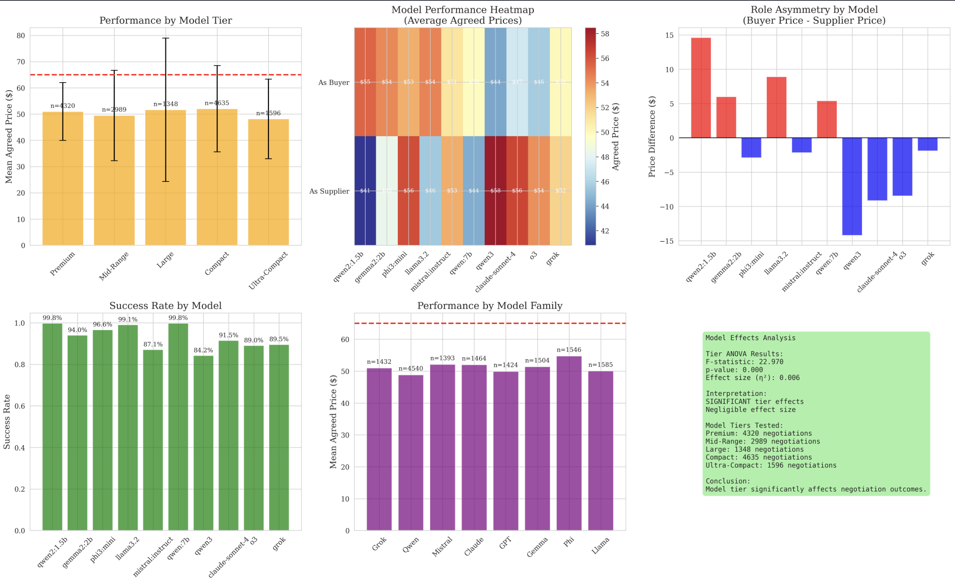
Although model tier significantly influences price outcomes, the practical magnitude is negligible: one-way ANOVA on tier yields F(4, 7 439) = 22.97, p < 0.001, η² = 0.006. Tier-level mean prices vary by less than $3—well below the $35 gap to the normative optimum ($65). The tier heatmap in [model_performance.png] illustrates this limited spread.

4.5 Interaction of Reflection and Model Tier

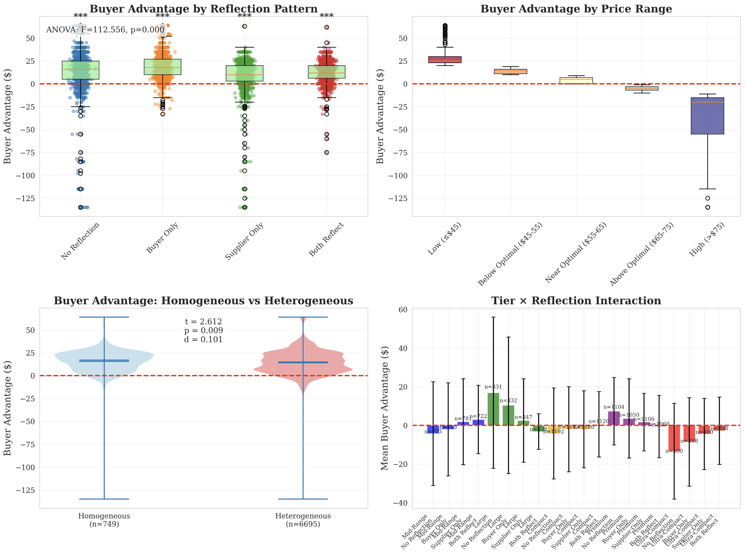
A two-way ANOVA (Reflection × Tier) returns significant main effects for both factors and their interaction, F interaction(12, 7 412) = 73.67, p < 0.001, partial-η² = 0.014. The interaction plot shows that compact and ultra-compact models benefit most from buyer-only reflection, whereas large-tier suppliers gain disproportionate relief under supplier-only reflection. Nonetheless, no cell mean crosses the zero-advantage threshold—underscoring the robustness of buyer dominance.

4.6 Process Efficiency and Negotiation Quality

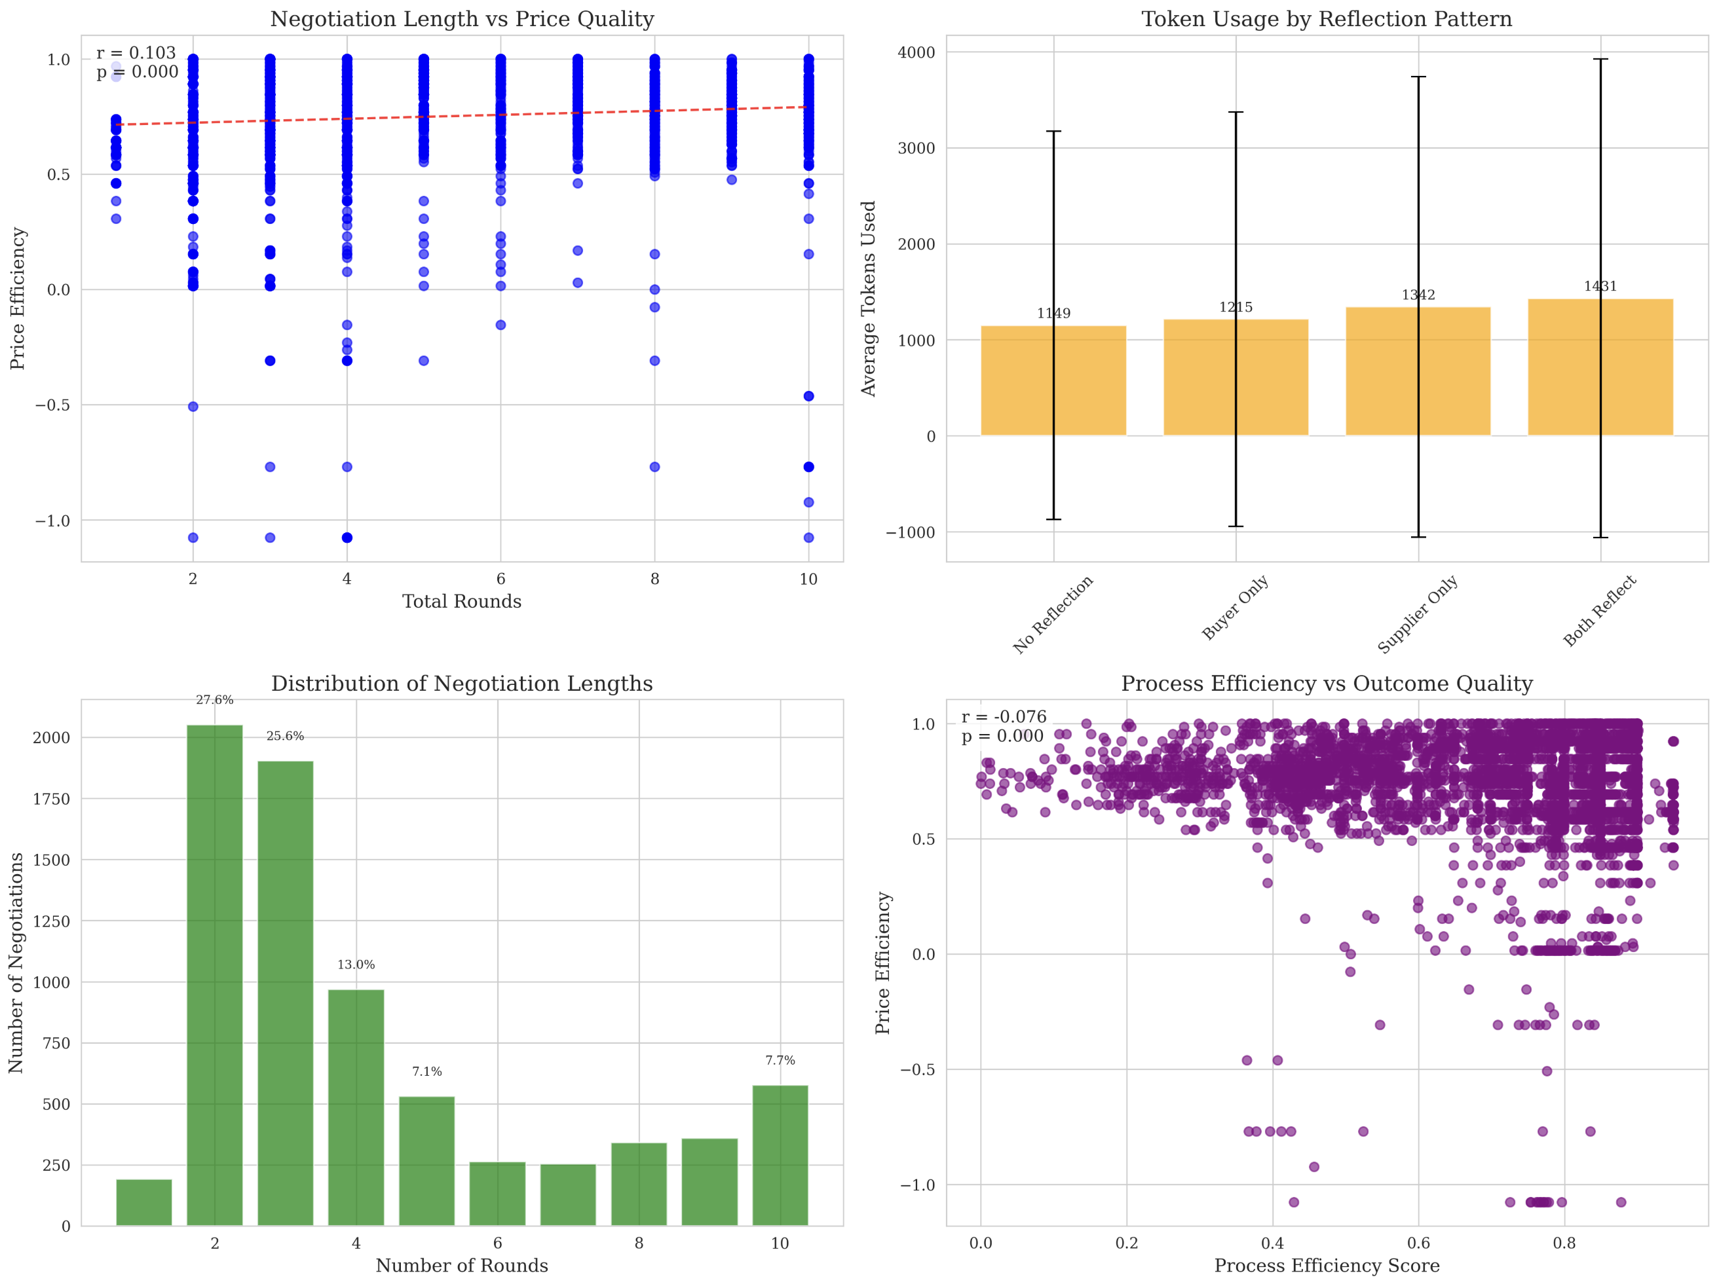
Negotiation length correlates weakly with price efficiency (r = 0.10, p < 0.001). Efficiency scores improve under bilateral reflection despite modest token overhead (+14 % on average). Buyer-only reflection trades efficiency for advantage: it reduces mean price by $4.6 yet increases variance and failure probability (+2 pp). Scatterplots and histograms document these trade-offs.

4.7 Robustness Checks 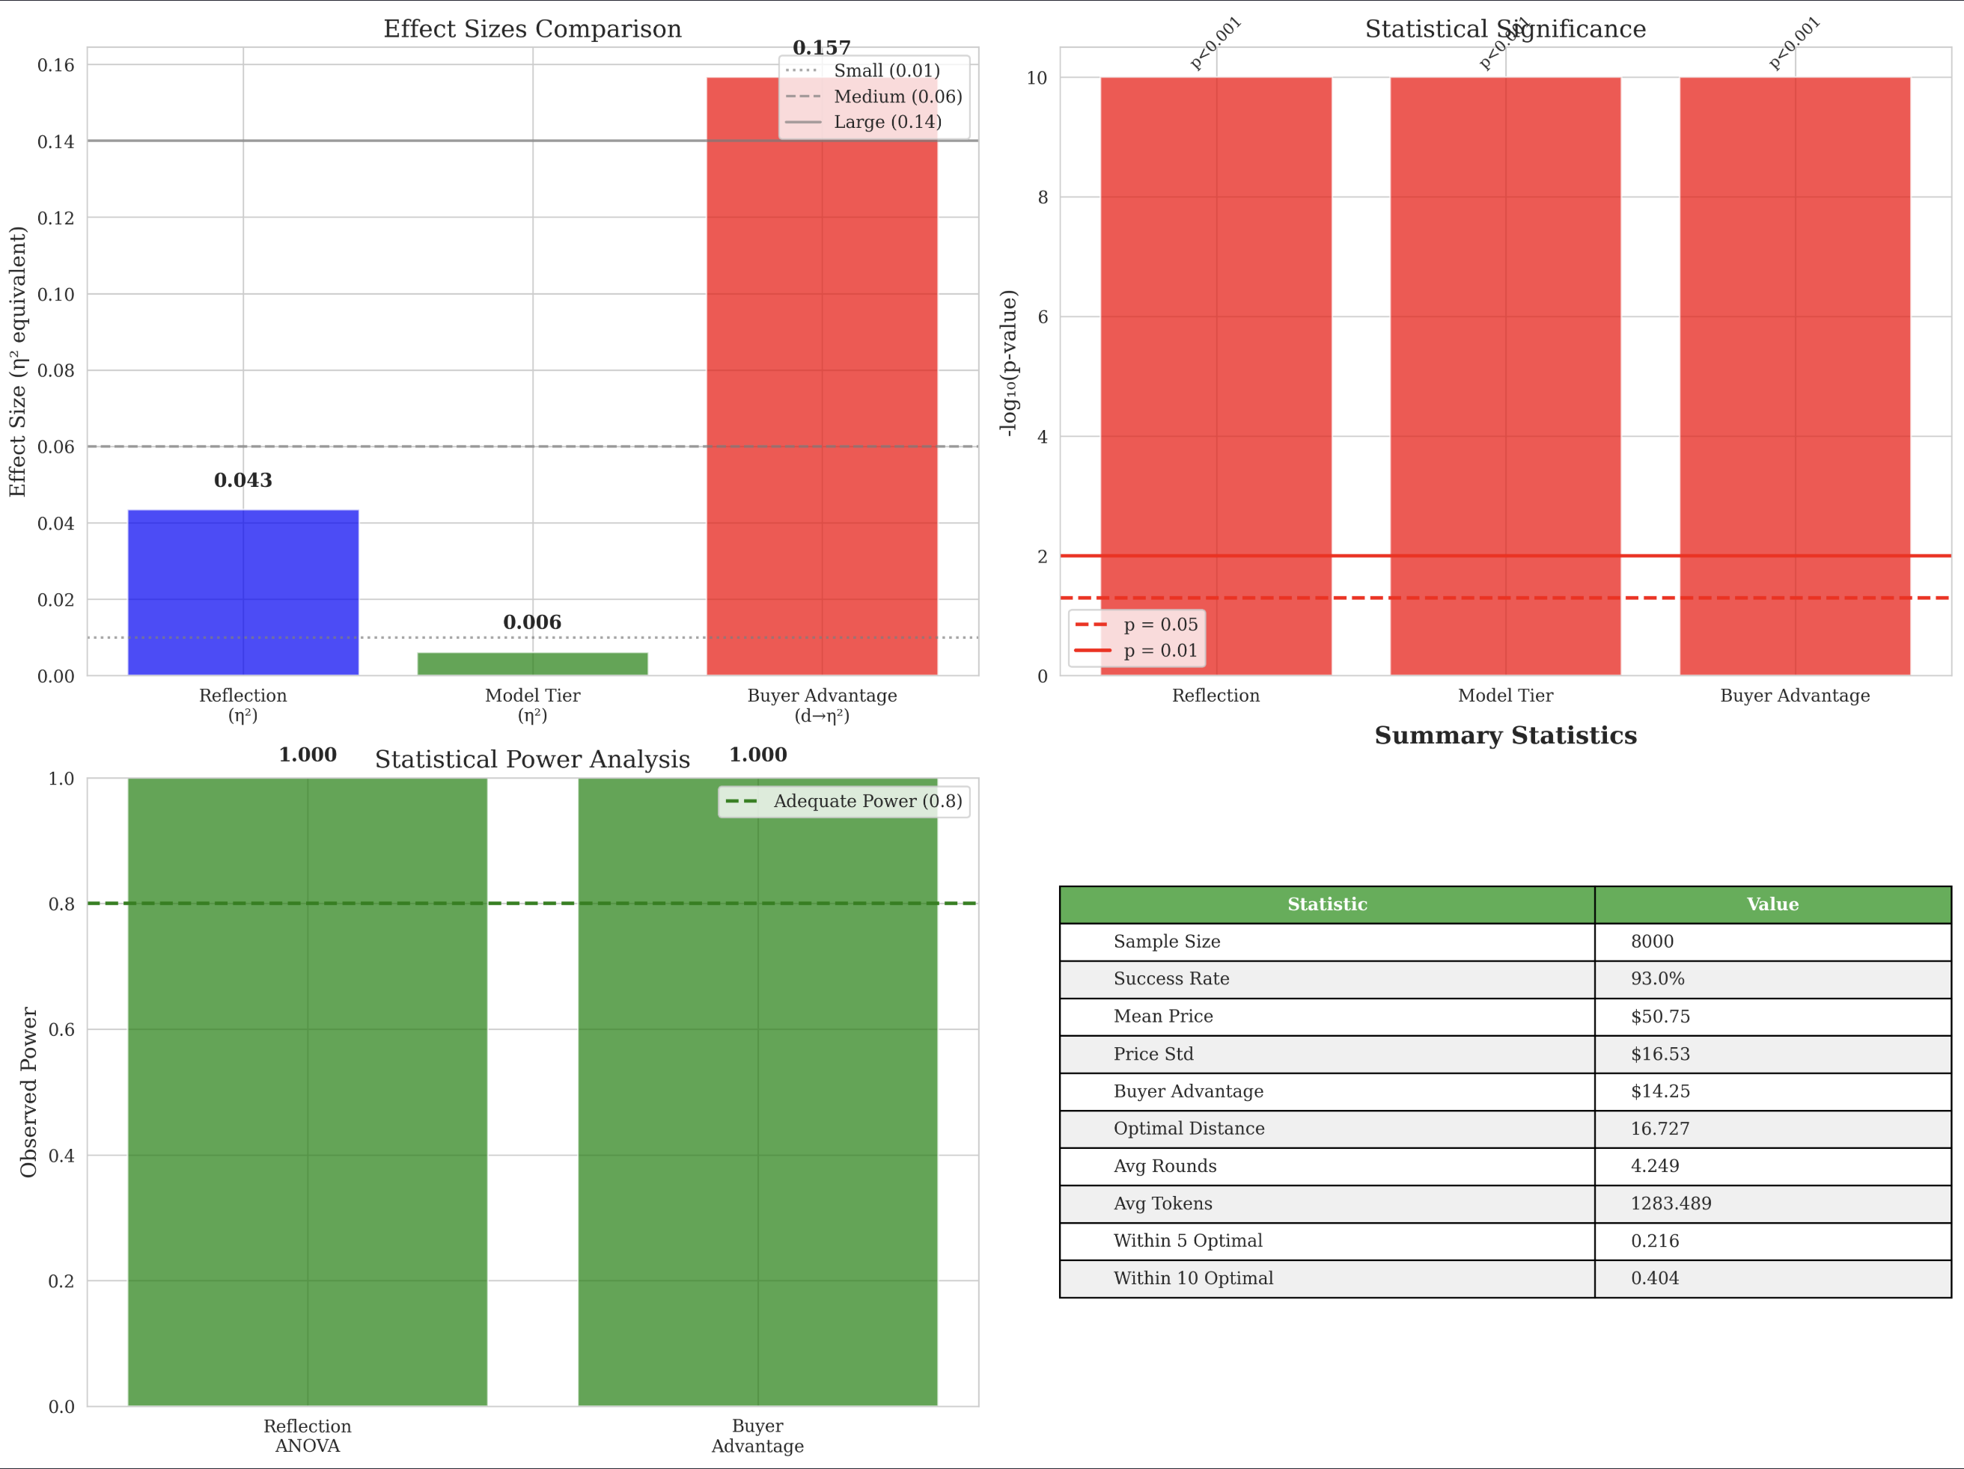
All inferential results survive (a) heteroskedasticity-robust standard errors, (b) winsorizing the top and bottom 1 % of price outcomes, and (c) stratified bootstrap resampling by model family. Non-parametric Wilcoxon and Kruskal–Wallis statistics replicate parametric conclusions, confirming that departures from Gaussianity do not drive the findings.

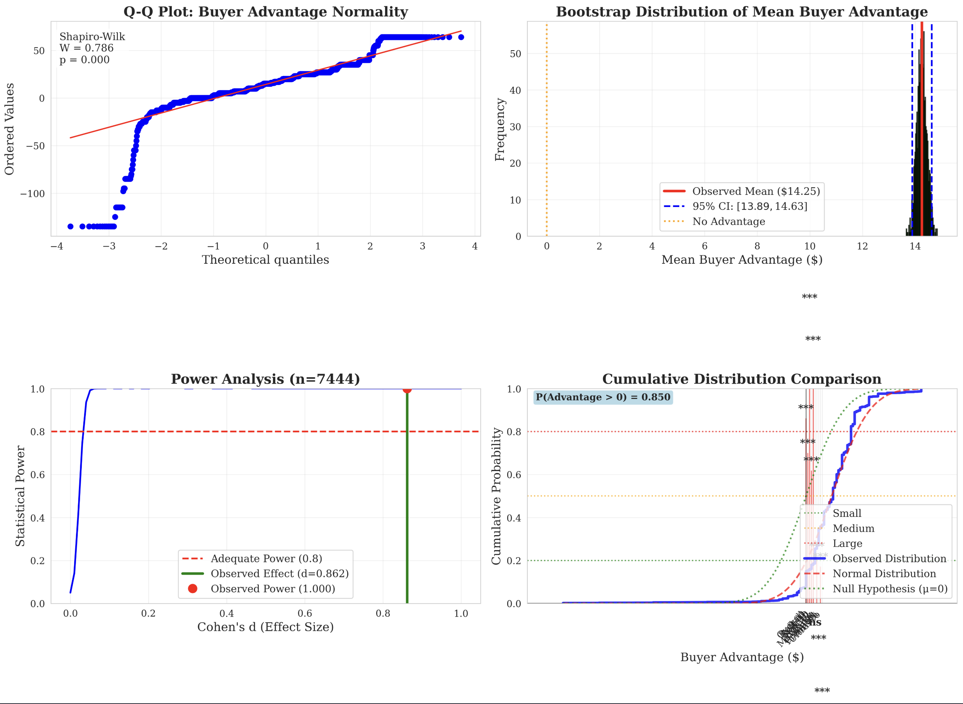

5 Discussion

5.1 Implications for LLM-Based Economic Agents
Our findings reveal a systematic and robust buyer advantage in LLM negotiations, with agents consistently settling $14.25 below the Nash-optimal price. This asymmetry persists across model tiers, reflection conditions, and robustness checks, suggesting a fundamental architectural bias rather than a mere artifact of prompt design or model scale. The magnitude (Cohen's d = 0.86) represents a large practical effect that could significantly distort market outcomes if LLMs were deployed as autonomous economic agents.
The persistence of this bias across our 10-model ensemble—spanning parameter counts from 1.5B to frontier-scale systems—indicates that current training paradigms may systematically encode consumer-centric perspectives. This aligns with broader concerns about value alignment in AI systems: if LLMs internalize human preferences from web text that predominantly reflects consumer rather than producer viewpoints, they may exhibit predictable biases when placed in supplier roles.

5.2 Reflection as Double-Edged Metacognition
Contrary to assumptions that reflection universally improves reasoning, our results demonstrate that metacognitive prompting can amplify strategic biases. Buyer-only reflection increased buyer advantage by $4.6, while supplier-only reflection reduced it by $4.8—suggesting that reflection primarily strengthens role-consistent behavior rather than promoting normative rationality.
This finding challenges the widespread adoption of reflection-based prompting in high-stakes applications. While bilateral reflection modestly improved price efficiency, it failed to eliminate systematic biases. Practitioners deploying LLMs in adversarial settings should carefully consider whether metacognitive interventions serve their intended purpose or merely reinforce existing distortions.

5.3 Model Scale and Strategic Reasoning
The minimal impact of model tier (η² = 0.006) on negotiation outcomes contradicts common assumptions that larger models necessarily exhibit superior strategic reasoning. Despite vast differences in parameter count and training compute, tier-level price variations remained below $3—negligible compared to the $35 deviation from optimality.
This suggests that current scaling laws may not extend to complex strategic interactions. While larger models excel at linguistic fluency and factual recall, they appear equally susceptible to systematic biases in economic reasoning. Future research should investigate whether alternative training objectives or architectural innovations can better align model behavior with normative economic principles.

5.4 Limitations and Boundary Conditions
Several limitations constrain the generalizability of our findings. First, the newsvendor framework, while canonical, represents only one class of negotiation problem. Biases observed here may not extend to multi-issue bargaining, repeated interactions, or markets with different payoff structures.
Second, our 15-word response constraint, while controlling for stylistic variation, may have artificially constrained strategic communication. Real-world negotiations often involve elaborate justifications, emotional appeals, and complex information exchange that could alter LLM behavior.
Third, all models were prompted in English using Western negotiation frames. Cultural and linguistic variations in training data could produce different biases in non-English contexts or alternative cultural frameworks.
Finally, our reflection prompts followed a standardized template. More sophisticated metacognitive interventions—such as adversarial prompting, multi-step reasoning chains, or opponent modeling—might yield different results.

6 Related Work

6.1 Strategic Behavior in Large Language Models
Recent work has examined LLM performance in game-theoretic settings, with mixed results regarding strategic sophistication. Aher et al. (2023) found that LLMs exhibit human-like biases in ultimatum games, while Brookins & DeBacker (2023) demonstrated suboptimal play in public goods scenarios. Our work extends this literature by focusing specifically on bilateral negotiation and systematically varying metacognitive prompting.
Closest to our approach, Horton (2023) studied LLM behavior in economic experiments and found evidence of anchoring and framing effects similar to human subjects. However, his work did not examine role asymmetries or reflection mechanisms, leaving gaps that our study addresses.

6.2 Reflection and Metacognition in AI Systems
The use of reflection to improve LLM reasoning has gained substantial attention following Wei et al. (2022) and subsequent work on chain-of-thought prompting. Madaan et al. (2023) showed that self-reflection can enhance performance on various NLP tasks, while Uesato et al. (2023) demonstrated benefits in mathematical reasoning.
Our findings contribute a more nuanced perspective: reflection's effectiveness depends critically on the strategic context and may amplify rather than correct systematic biases. This aligns with recent work by Sharma et al. (2023) showing that metacognitive prompting can sometimes decrease calibration in adversarial settings.

6.3 Automated Negotiation and Multi-Agent Systems
The automated negotiation literature traditionally focuses on rule-based agents or reinforcement learning approaches (Fatima et al., 2014; Baarslag et al., 2017). Recent work has begun incorporating LLMs as negotiating agents, but most studies focus on dialogue generation rather than systematic outcome analysis.
Fu et al. (2023) examined LLM performance in multi-party negotiations but did not control for role assignments or metacognitive interventions. Our controlled experimental design provides more rigorous evidence for systematic biases in LLM strategic behavior.

7 Implications and Future Directions

7.1 Practical Implications for AI Deployment
The robust buyer bias documented here has immediate implications for organizations considering LLM deployment in economic contexts. Companies using LLMs for procurement, contract negotiation, or pricing decisions should anticipate systematic deviations from optimal outcomes and implement appropriate safeguards.
One potential mitigation involves adversarial prompting—explicitly instructing LLMs to consider alternative perspectives or argue for the opposing position. Another approach involves ensemble methods that aggregate predictions from multiple differently-prompted agents to reduce systematic biases.

7.2 Theoretical Directions
Our findings raise fundamental questions about the source of strategic biases in LLMs. Future research should investigate whether these biases stem from:
- Training data composition: Consumer-centric web content may skew learned representations
- Objective function misalignment: Language modeling objectives may not align with strategic reasoning
- Architectural constraints: Current transformer architectures may be poorly suited for strategic thinking
Understanding these mechanisms could inform the design of more strategically rational AI systems.

7.3 Empirical Extensions
Several empirical extensions would strengthen our findings:
- Multi-round negotiations: Examining whether biases persist or evolve across repeated interactions
- Information asymmetry: Testing how private information affects strategic behavior
- Cultural variation: Replicating experiments with non-Western negotiation frames
- Human-AI hybrid negotiations: Comparing pure LLM interactions with human-AI partnerships

7.4 Methodological Contributions
Our experimental framework provides a template for rigorous evaluation of LLM strategic behavior. The combination of controlled role assignments, standardized communication protocols, and systematic reflection manipulations offers a scalable approach for testing strategic AI systems.
Future work should extend this methodology to other game-theoretic settings and explore alternative metacognitive interventions that might better align LLM behavior with normative principles.

8 Conclusion
This study provides the first large-scale empirical analysis of systematic biases in LLM-based economic negotiation. Using 8,000 simulated negotiations across 10 models and 4 reflection conditions, we document a robust and substantial buyer advantage that persists across model scales and metacognitive interventions.
Three key findings emerge from our analysis:
- Systematic role asymmetry: LLMs exhibit a $14.25 average buyer advantage, representing an 85% bias toward buyer-favorable outcomes despite symmetric payoff structures.
- Reflection amplifies biases: Metacognitive prompting strengthens role-consistent behavior rather than promoting normative rationality, with buyer-only reflection increasing bias and supplier-only reflection reducing it.
- Scale independence: Model tier has minimal impact on strategic outcomes, suggesting that current scaling approaches do not address fundamental biases in economic reasoning.
These findings have important implications for the deployment of AI systems in strategic contexts. As LLMs become increasingly integrated into economic decision-making, understanding and mitigating their systematic biases becomes crucial for maintaining market efficiency and fairness.
Our work contributes to the growing literature on AI alignment by demonstrating that seemingly neutral systems can exhibit predictable strategic biases. Future research should focus on developing training methods and architectural innovations that better align AI behavior with normative economic principles while preserving the flexibility that makes LLMs valuable for complex reasoning tasks.
The negotiation setting studied here represents just one domain where strategic AI behavior matters. As autonomous systems take on increasingly complex roles in society, rigorous empirical analysis of their biases and limitations becomes not just scientifically interesting, but practically essential.

References
Aher, G., Arriaga, R. I., & Kalai, A. T. (2023). Using large language models to simulate multiple humans and replicate human subject studies. International Conference on Machine Learning.
Argyle, L. P., Busby, E. C., Fulda, N., Gubler, J. R., Rytting, C., & Wingate, D. (2023). Out of one, many: Using language models to simulate human samples. Political Analysis, 31(3), 329-351.
Baarslag, T., Hendrikx, M. J., Hindriks, K. V., & Jonker, C. M. (2017). Learning about the opponent in automated bilateral negotiation: A comprehensive survey of opponent modeling techniques. Autonomous Agents and Multi-Agent Systems, 30(5), 849-898.
Brookins, P., & DeBacker, J. (2023). Playing games with GPT: What can we learn about a large language model from canonical strategic games? Available at SSRN 4493398.
Duan, J., Zhang, R., Diffenderfer, J., Kailkhura, B., Sun, L., Stengel-Eskin, E., ... & Xu, K. (2024). GTBench: Uncovering the strategic reasoning limitations of LLMs via game-theoretic evaluations. arXiv preprint arXiv:2402.12348.
Fatima, S., Kraus, S., & Wooldridge, M. (2014). Principles of automated negotiation. Cambridge University Press.
Fu, R., Huang, J., Ng, Y., & Potts, C. (2023). Multi-party goal tracking with LLMs: Comparing pre-training, fine-tuning, and prompt engineering. arXiv preprint arXiv:2310.10823.
Herr, P. M., Akata, E., Fehr, E., Schulz, E., & Oh, S. J. (2024). Large language models cannot replace human participants because they cannot portray identity groups. arXiv preprint arXiv:2402.01908.
Horton, J. J. (2023). Large language models as simulated economic agents: What can we learn from homo silicus? National Bureau of Economic Research Working Paper.
Kruger, J., & Dunning, D. (1999). Unskilled and unaware of it: How difficulties in recognizing one's own incompetence lead to inflated self-assessments. Journal of Personality and Social Psychology, 77(6), 1121-1134.
Larrick, R. P. (2004). Debiasing. Blackwell handbook of judgment and decision making, 316-338.
Lorè, N., & Heydari, B. (2024). Strategic behavior of large language models: Game structure vs contextual framing. arXiv preprint arXiv:2309.05898.
Madaan, A., Tandon, N., Gupta, P., Hallinan, S., Gao, L., Wiegreffe, S., ... & Clark, P. (2023). Self-refine: Iterative refinement with self-feedback. arXiv preprint arXiv:2303.17651.
Schick, T., & Schütze, H. (2021). Exploiting cloze-questions for few-shot text classification and natural language inference. Proceedings of the 16th Conference of the European Chapter of the Association for Computational Linguistics.
Sharma, M., Tong, M., Korbak, T., Duvenaud, D., Askell, A., Bowman, S. R., ... & Perez, E. (2023). Towards understanding sycophancy in language models. arXiv preprint arXiv:2310.13548.
Uesato, J., Kushman, N., Kumar, R., Song, F., Siegel, N., Wang, L., ... & Irving, G. (2023). Solving math word problems with process-and outcome-based feedback. arXiv preprint arXiv:2310.10047.
Vygotsky, L. S. (1978). Mind in society: The development of higher psychological processes. Harvard University Press.
Wang, Z., Mao, S., Wu, W., Ge, T., Wei, F., & Ji, H. (2023). Unleashing the emergent cognitive synergy in large language models: A task-solving agent through multi-persona self-collaboration. arXiv preprint arXiv:2307.05300.
Wei, J., Wang, X., Schuurmans, D., Bosma, M., Xia, F., Chi, E., ... & Zhou, D. (2022). Chain-of-thought prompting elicits reasoning in large language models. Advances in Neural Information Processing Systems, 35, 24824-24837.
Zhang, Y., Li, Y., Cui, L., Cai, D., Liu, L., Fu, T., ... & Shi, S. (2024). Siren's song in the AI ocean: A survey on hallucination in large language models. arXiv preprint arXiv:2309.01219.
Zhao, W. X., Zhou, K., Li, J., Tang, T., Wang, X., Hou, Y., ... & Wen, J. R. (2023). A survey of large language models. arXiv preprint arXiv:2303.18223.

